Otter Hydraulic Fluid Investigations November 2019
- Overview
Investigations to determine the cause(s) of high levels of pelagic fluid usage was carried out from the Eider platform between the 10th and 14th November 2019.
Investigations were carried out as per JSP-SUB-005.
With all Otter Wells Online (P1, P2, P3 and I2) the system was found as follows:
- LP1, LP2 and HP1 HPU supplies are in use.
- HP2 is isolated due to leak.
- All SCMs LP/HP DCV Selector are selected on Line A by default.
- LP Pump Runtime Frequency is 42 minutes
- HP Pump Runtime Frequency is 40 minutes
- Fluid Usage is in the region of 350 litres per day which is fairly consistent with wells in stable state.

- Otter HP System Summary
The HP Supply operates Otter Wells P1, P2 and P3 SCSSV’s only.
HP2 Line is formally isolated at the Otter HPU (Valves 5003 and 5004) due to a previously identified leak. Therefore, no investigation was carried out on HP2 as part of this program.
The HP regulated pressure should be 517 Bar Topside. The regulated HP1 pressure can be seen to range from 510 to 540 over a period of time.
There is a consistent fluid use of ~40 litres per day which is attributed to the HP system. This leak rate is present with the SCCSVs Closed or Open. This confirms that:
- The HP leak is upstream of SCMs on the supply side.
- No losses can be attributed to the SCSSV control lines.
2.1 HP System Trend
On 10/11 at 1735 a spurious North Cormorant ESD resulted in LP HPU SOVS de-energising and the LP system vented and remained so overnight. All SCSSVs were in closed position at this time.
The HP Pump continued to operate every 45 minutes to maintain pressure and the HPU supply Tank level continued to drop at a rate equivalent to 4% a day.
As the LPs system was offline, this confirms that the HP1 supply has a leak rate of 40 litres per day.
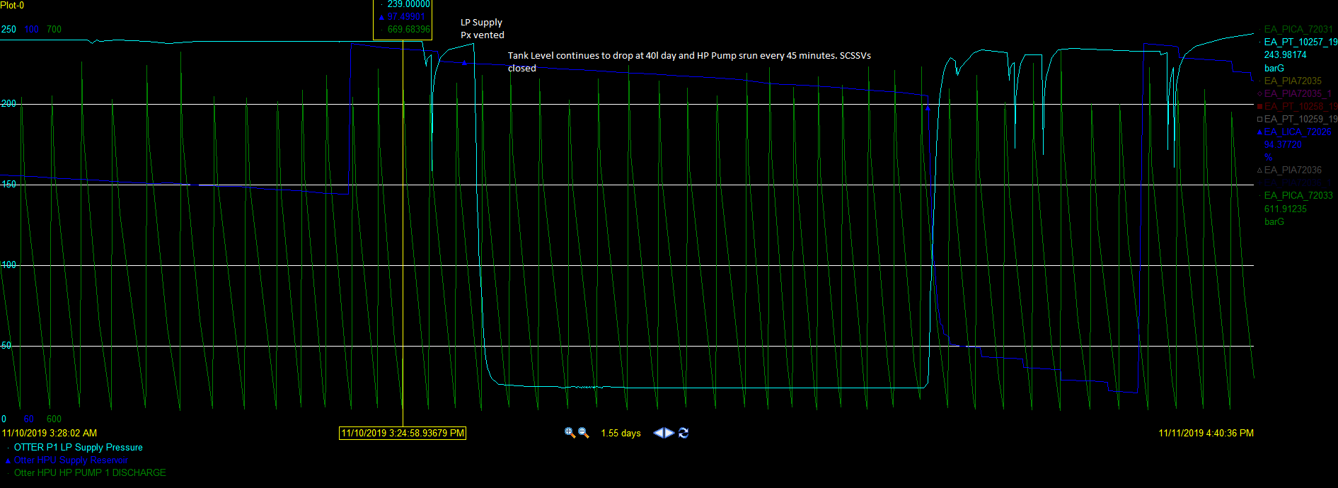
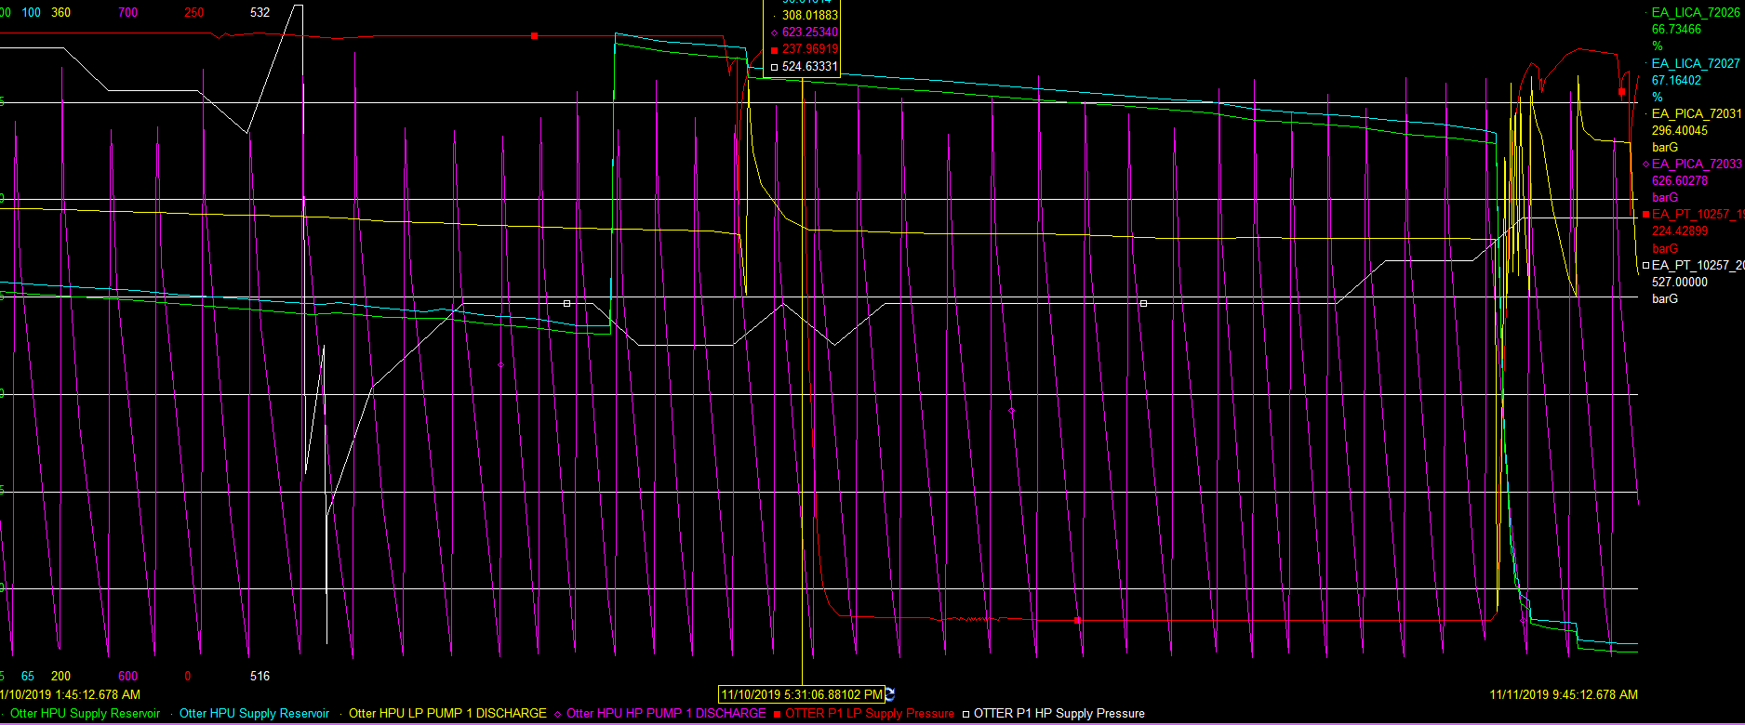

- Otter LP System Summary
The LP system supplies every subsea valve apart from the SCSSVs.
The LP system is also used to operate the Otter MPP Recycle valve FCV-1200-04.
Both dual redundant LP1 and LP2 supplies are operational.

  - Otter LP Supply
Following completion of Otter WITS testing 11th November, there was no LP demand on the system. The LP Pumps did not run for over 12 hours and this was only due to valve ops being made.
A screenshot showing the subsea valve setup following the WITs is shown below.
This confirms there is no LP Supply leak upstream of SCMs and that the leak path must be at 1 or more LP subsea valves.
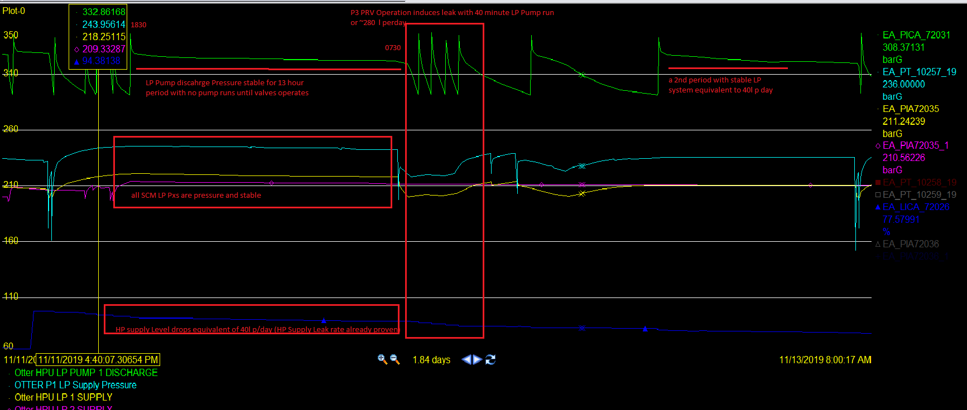
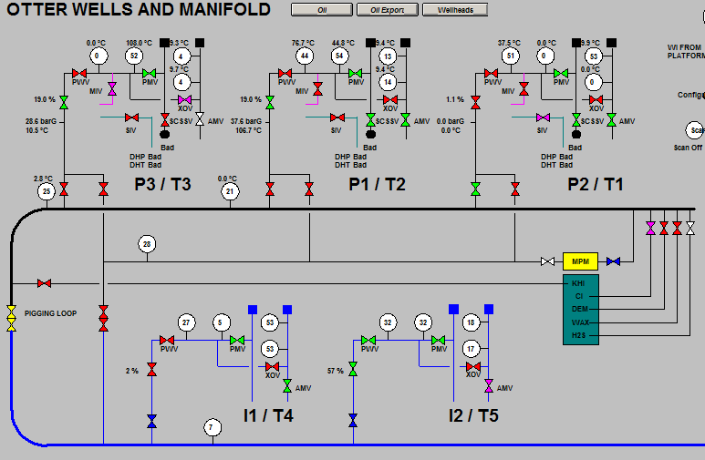
Fig. Screenshot of subsea valve on completion of WITs and a stable LP supply

  - LP Valve Investigation

In order to ascertain which valves(s) contributed to the fluid losses, LP valves were either:

- Discounted. If they are not normally OPEN during production OR had been in the OPEN position following the WITS testing (11th-12th November)

- Tested as part of JSP-SUB-005.
A Summary of Valve Status and findings are in table below.
 | P1 | P2 | P3 | I1 | I2
PMV | OPEN during period with Stable LP.  Also tested on 13th. | OPEN during period with Stable LP. OPEN for additional WIT checks | OPEN during period with Stable LP.  Also tested on 13th. | Well not in use | Found OPEN during a Stable LP Period
PWV | Tested. All 3 PWVs left Open with no issues. | Tested. All 3 PWVs left Open overnight with no issues. | Tested. All 3 PWVs left Open with no issues. | Well not in use | Found OPEN during a Stable LP Period
AMV | Found OPEN during a Stable LP Period. OPEN during most of test period. | Found OPEN during a Stable LP Period. OPEN during most of test period. | Found OPEN during a Stable LP Period. OPEN during most of test period. | Well not in use | Found OPEN during a Stable LP Period
SIV | Tested | Tested | Tested
MIV | Discounted. Only used at start-up | Discounted. Only used at start-up | Discounted. Only used at start-up
XOV | Discounted. Not normally Open. | Discounted. Not normally Open. | Discounted. Not normally Open. | Discounted. Not normally Open. | Discounted. Not normally Open.
PRV | Tested | Tested | Increased Fluid usage noted. See section 3.3
TRV | Discounted. Not normally Open | Discounted. Not normally Open | Tested

 | MANIFOLD
MPMV | Tested.
CIV | Tested.

  - P3 Production Routing Valve (PRV) XV-12059-7.
Following actuation of the P3 PRV (XV-12059-7) 12th November at 0800, a leak of ~300 litre per day leak rate was evident. The LP Pump ran at 40 min intervals. Tank Level dropped approx. 4.5% in 3 hours equivalent to an LP loss of approx. 300 litres per day. P3 PRV was closed at 1100 and the LP pump runtime frequency reduced to normal.
Attempted to stem the leak by ‘re-commanding’ the already Open valve to Open in order to reseat the SCM DCV. This was unsuccessful.
Carried out a 2nd test and opened the PRV from 1400 to 1630. The Fluid use was still above average but on this occasion leak rate had reduced to in the region of ~100l per day.
This would suggest that the cause of leak is a DCV issue with in the SCM.
With the P3 PRV in closed position overnight, LP pumps did not run and the tank level dropped to 40litres per day which is the system baseline figure.
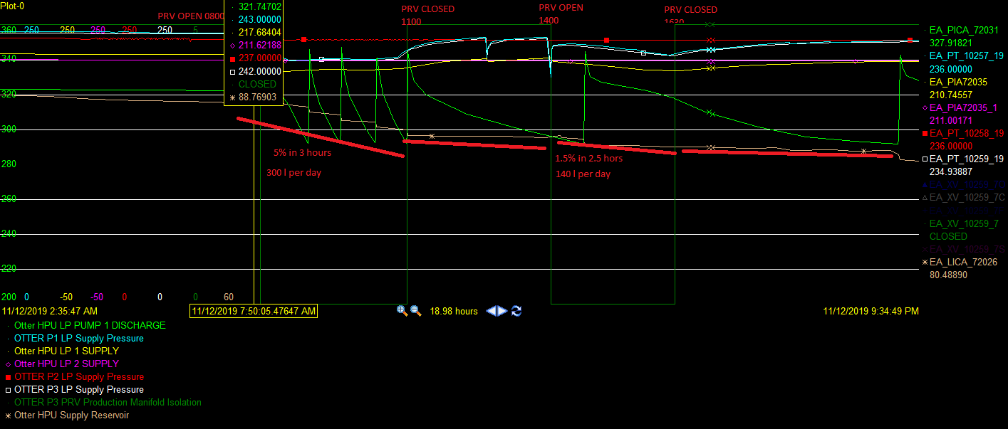

On the 13th November at 1100, the P13 PRV was cycled 3 times to try and reseat the SCM DCV and left in OPEN position for an overnight test in order to quantify fluid use.
Note, PI was down in the evening of the 13th so data was not trended.
Supply Tank on 13/11 at 2pm was 97%. At 0600 it was at 88%.
Total system Leak rate was 135 litres per day. 40 litres of this total is attributed to HP system and the remainder due to the P3 PRV and natural system usage.
P3 PRV CLOSED on 13th November at 0630 and work scope complete.

- MPP FCV Valve

The MPP accounts for additional fluid use of approximately 0.4l per step.

When Otter wells are back online then this can be monitored to determine the MPP Fluid usage. .

- Conclusion

- The HP system has no redundancy and there is a loss of integrity on the operational line HP1.

There is a confirmed HP1 Supply Leak of 40 litres per day.

No additional fluid use is attributed to SCSSVs.

HP2 leak, which has been isolated for some time, is also upstream of SCM.

- LP1 and LP2 supplies have negligible fluid use.

- The P3 Production Routing Valve (XV-12059-7) is suspect. 2 different leak rates were seen with the PRV in open position. Either approximately 300 litres per day or 100 litres per day.

There is an issue with the DCV during operation resulting in the larger leak which can be decreased by cycling the valve.

The smaller leak may still be the DCV not being fully seated but it may also be downstream of SCM.

- SCM DCVS. Although the only issue identified during this program was with the P3 PRV DCV. There is potential for every DCV in system to not fully seat and result in an identical leak rate.

- The LP and HP regulators are not maintaining pressure correctly. LP and HP pressure has been seen to range over time. The LP regulator could not be reduced further.

- Recommendations

- When North Cormorant restart Otter production then:

- Wait for LP system to recover at SCM before operating valves.
- Hydraulic Fluid use should be monitored during the well start-up process.
- Record times for each subsea valve operation to assist in identifying the valve at fault.
- Cycle the suspected valves which initiated the leak.

- Replace HPU Regulators 3401, 2402, 3501 and 3502.

- Consider routing P3 Well through Test Line so the P3 PRV can remain closed to eliminate this source of fluid loss.

- DSV to investigate and if possible repair the HP leaks on HP1 and HP2.

RISK. The HP system has no redundancy and the operational HP line has a loss of integrity, albeit a relatively minor one.

- A DSV would be required to investigate the P3 PRV issue any further.

- If wells can successfully be brought online with a stable and consistent fluid usage. Add a Pi Rate of Change alarm to notify people when there is a large increase in fluid usage over and above normal parameters.

Appendix A – System Leak Identification

The following tags can be monitor in Pi or DCS to help identify when fluid usage has increased.

LPA Pump Discharge: EX_PICA_72031
The LP Pump runs every 40 minutes if there is a leak. With stable usage it will seldom run.

HPU LPA Output: EA_PIA72035
HPU LPB Output: EA_PIA72035_1

The SCMs are all selected to the LPA supply by default.

LPA runs slightly higher than LPB. During a period with fluid losses, LPA will drop below LPB and remain below until the leak is stemmed.

Note. LPA will also drop below LPB during periods with valve ops but it will return quickly above LPB.

P1 SCM LP Px: EA-PT-10257_19
P3 SCM LP Px: EA-PT-10259_19

During a period with leak, the SCM Pxs will drop off and not build up again. It will run lower at ~222 Bar and be fairly sporadic.

Without losses then the LP Supply at SCM will stabilise at 240 Bar and be more stable.

HPU Supply Tank Level – EA_LICA_72026

